Practice challenge
LO5 – Manage & Control
Malamski,Dimitar D.S.
mitemalamata@gmail.com

Contents
Introduction 2
Sprints 2
Sprint 1 2
Sprint 2 2
Evidence 1 - Making the modelling pipeline transparent through a structured notebook workflow 2
Evidence 2 - Using an interpretable baseline model 3
Evidence 3 - Improving interpretability through feature selection 3
Evidence 4 - Explaining model behavior through feature importance 4

Introduction
This document presents the evidence for Learning Outcome 5 ( Manage & Control ) in my Practice Challenge project - Student Dropout Prediction. The purpose of this document is to show how I demonstrated this learning outcome by making the AI solution transparent, interpretable, explainable, and transferable within its context. The evidence is organized by sprint, with each section describing the activity, the result, and why it is relevant to the learning outcome.

Sprints

Sprint 1
There was no progress made relating to Manage & Control during Sprint 1.

Sprint 2

Evidence 1 - Making the modelling pipeline transparent through a structured notebook workflow
What this evidence is
This evidence shows how I made the full modelling process transparent and reproducible through a structured notebook.
What I did
I documented the entire workflow in a step-by-step notebook, including data loading, cleaning, target preparation, exploratory analysis, preprocessing, model training, evaluation, ethical analysis, and threshold tuning. Each stage was clearly separated, explained, and supported with code, outputs, and written interpretation.
Result
This created a transparent record of how the input data was transformed into trained prediction models. The process can be followed, reviewed, and continued by others more easily because the steps are explicitly documented.
Why this is relevant to the Learning Outcome
This demonstrates manage and control because I made the development process reproducible and understandable to others, which supports both transparency and transferability.
Attached evidence

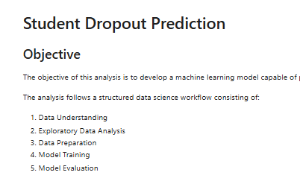

Evidence 2 - Using an interpretable baseline model
What this evidence is
This evidence shows how I ensured that the solution included an interpretable reference model.
What I did
I implemented Logistic Regression as the baseline model for the prediction task. Logistic Regression is easier to understand than more complex ensemble models and therefore served as a transparent reference point when comparing the behavior and performance of the other models.
Result
This provided an interpretable starting point for the AI solution and made later comparisons more meaningful, because the project did not rely only on more complex black-box models.
Why this is relevant to the Learning Outcome
This demonstrates manage and control because I included an interpretable model in the solution, supporting human understanding of the project and making the results easier to relate to the problem context.
Attached evidence
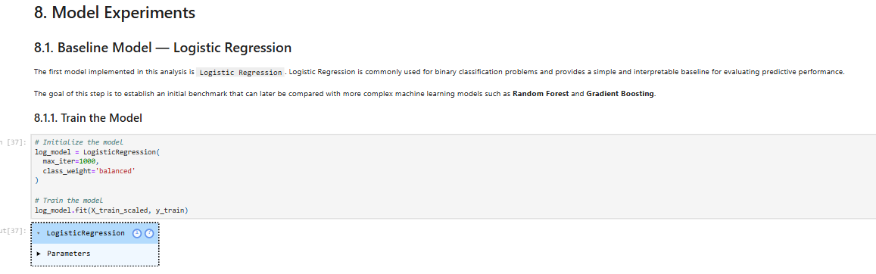

Evidence 3 - Improving interpretability through feature selection
What this evidence is
This evidence shows how I improved the interpretability of the solution by reducing model complexity.
What I did
I applied SelectKBest to identify the most informative predictors and reduce the number of features used by the Logistic Regression model. I then compared the baseline model with the selected-feature version to evaluate whether a simpler model could still perform well.
Result
The selected-feature Logistic Regression model achieved stronger performance while using fewer variables. This made the solution easier to understand and interpret without reducing predictive quality.
Why this is relevant to the Learning Outcome
This demonstrates manage and control because I used feature selection to increase interpretability and make the solution easier for humans to understand and review.
Attached evidence
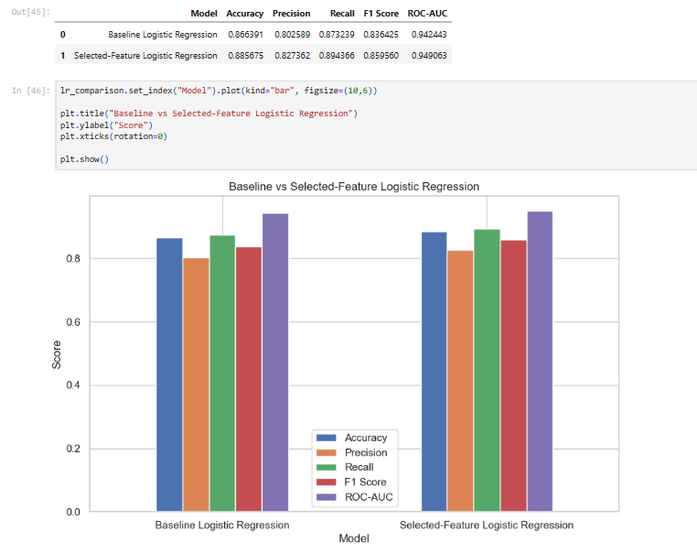

Evidence 4 - Explaining model behavior through feature importance
What this evidence is
This evidence shows how I used model-based explainability techniques to understand which variables influenced the predictions most.
What I did
For the Random Forest model, I extracted and visualized feature importance scores. This allowed me to identify which predictors had the strongest influence on the model’s decisions, such as first-semester approved curricular units, first-semester grades, tuition fee status, and age at enrollment.
Result
This made the behavior of a more complex model more understandable and showed that the model relied mainly on academically meaningful predictors rather than arbitrary patterns.
Why this is relevant to the Learning Outcome
This demonstrates manage and control because I applied an explainability method to make the decision-making process of a more complex model more transparent.
Attached evidence
